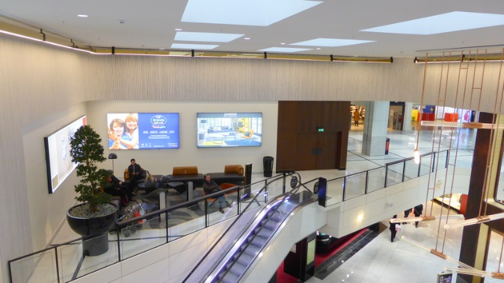 | 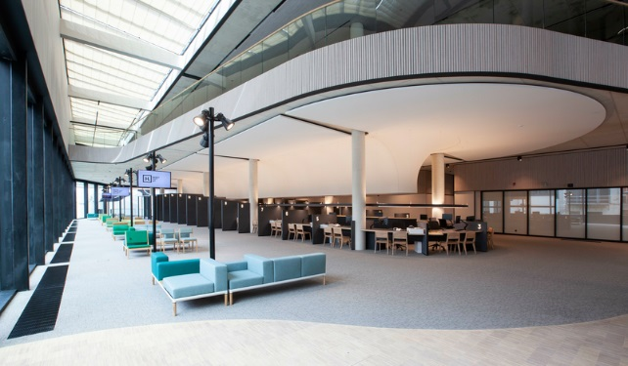
Hunter Douglas HeartFelt® Linear felt wall

- Product description (various configs, modulations)
HeartFelt® Linear felt wall is a linear box shaped panel made from non-woven thermo-formable virgin PES fibres. Dimension (bxh) 40x55mm with an open joint between the panels.
System module | Joint width | Openness %
200mm | 160mm | 80%
190mm | 150mm | 79%
180mm | 140mm | 78%
170mm | 130mm | 76%
160mm | 120mm | 75%
150mm | 110mm | 73%
140mm | 100mm | 71%
130mm | 90mm | 69%
120mm | 80mm | 67%
110mm | 70mm | 63%
100mm | 60mm | 60%
90mm | 50mm | 55%
80mm | 40mm | 50%
70mm | 30mm | 43% ¹⁾
60mm | 20mm | 33%
50mm | 10mm | 20%
1⁾ comparable to Luxalon® 30BD/30BXD panels

The carriers into which the panels are clipped are made from transparent coated (7178) or black (1863) aluminium (EN AW5050) with a height of ca 62mm, total system depth 85mm.

HeartFelt® Linear felt wall panels are available in 5 shades of grey and 5 earth-tones. The shades in colour are achieved by varying the ratio between the white, black and/or brown fibres in the mix of the base material.

HD Colour codes
Shades of Grey |  | Earth Tones
White | 7593 | Crème | 7575
Light grey | 7596 | Light brown | 7576
Middle grey | 7597 | Middle brown | 7577
Dark grey | 7598 | Dark brown | 7578
Black | 7594 | Umber | 7579

Other colours and or finishes may be introduced in a later stage.

HeartFelt® colours

Shades of Grey
 | 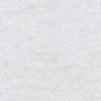  7593 White | 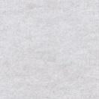  7596 Light Grey | 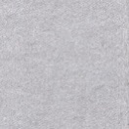  7597 Medium Grey | 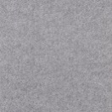  7598 Dark Grey | 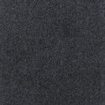  7594 Black

Earth Tones
 | 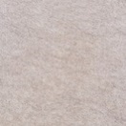  7575 Crème | 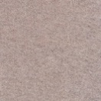  7576 Light Brown | 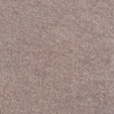  7577 Medium Brown | 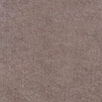  7578 Dark Brown | 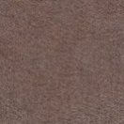  7579 Umber

Technical drawing
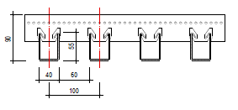
Module 100
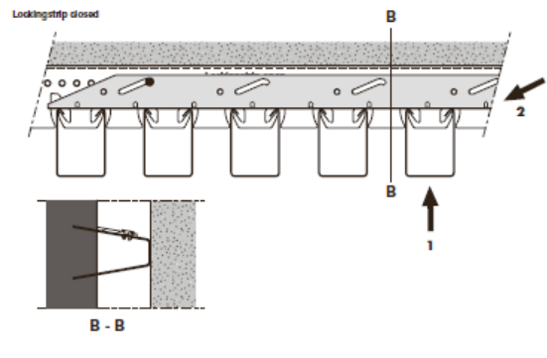
HeartFelt® Wall locking strip

- Panels
  - Dimension 40x55mm (40HL50) with the upper flanges pointing inward. The panels are supported by the prongs on the inner corner of the flanges and not by the edges of the flanges.
  - Minimum panel length 1000mm. Maximum panel length 6000mm.
Note: it is recommended to provide support for panels >4500mm during installation or demounting.
- Carriers
  - 0.95mm aluminium
  - Available in transparent coated 7178 or black 1863
  - Modules from 50mm to 200mm in 10mm increments
  - Carrier length ca 5,-m (exact length depending in module)
Article code | Description | Length
332075 | HeartFelt AL carrier 1 M50 | 4995 mm
332076 | HeartFelt AL carrier 1 M60 | 4975 mm
332077 | HeartFelt AL carrier 1 M70 | 4965 mm
332078 | HeartFelt AL carrier 1 M80 | 4955 mm
332079 | HeartFelt AL carrier 1 M90 | 4945 mm
332080 | HeartFelt AL carrier 1 M100 | 4995 mm
332081 | HeartFelt AL carrier 1 M110 | 4945 mm
332082 | HeartFelt AL carrier 1 M120 | 4915 mm
332083 | HeartFelt AL carrier 1 M130 | 4935 mm
332084 | HeartFelt AL carrier 1 M140 | 4895 mm
332085 | HeartFelt AL carrier 1 M150 | 4945 mm
332086 | HeartFelt AL carrier 1 M160 | 4955 mm
332087 | HeartFelt AL carrier 1 M170 | 4925 mm
332088 | HeartFelt AL carrier 1 M180 | 4855 mm
332089 | HeartFelt AL carrier 1 M190 | 4935 mm
332090 | HeartFelt AL carrier 1 M200 | 4995 mm

- Accessories
  - Al Panel splices, transparent coated 7178.
Note: Panel splicing is independent from carrier position!
  - Al Carrier splices, transparent coated 7178 or black 1863.
  - End caps from 6mm felt material in the same colours as the panels
  - Al Locking strips black 1863 and push nails black 1858
- Spans
  - Panel span (ctc distance of the carriers): 800mm
  - Panel cantilever (distance from panel end to 1st carrier): 150mm
  - Carrier span (ctc distance of the fixings): 750-800mm
  - Carrier cantilever (distance from carrier end to 1st fixing): 300mm
- Properties
  - Unique revolutionary product. Up till now, not existing in the wall/ lining market
  - Based on proprietary and patented technology
  - Has a “soft” look and creates a warm and comfortable ambiance
  - Acoustic performance comparable to similar aluminium perforated ceilings with non-woven acoustic tissue and open joints
  - Easy push-in installation of the panels. Installation of the system similar to linear felt ceilings. Demounting panels by peel-off from the prong
  - No special tools required. If necessary, panels can be cut-to-size on site with just a sharp knife
  - Light weight system:
Module | 40HL55
200mm | -
190mm | -
180mm | -
170mm | -
160mm | -
150mm | -
140mm | -
130mm | -
120mm | -
110mm | -
100mm | 1.5 kg/m²
90mm | 1.6 kg/m²
80mm | 1.8 kg/m²
70mm | 2.0 kg/m²
60mm | 2.3 kg/m²
50mm | 2.7 kg/m²

  - High impact resistance of the panels. Not easily damaged. However, the wall/ lining is not suited for use in sport hall applications where ball impact resistance is required

- Fire properties
Reaction to fire classification according EN 13501-1: Class B,s1,d0 (both grey and earth-tone colours).

- Acoustical properties
40HL55 panel
Module | α_{w} | NRC | SAA
100 mm | 0.45(H) | 0.44 | 0.44
90mm | 0.45(H) | 0.40 | 0.46
80 mm | 0.50(H) | 0.45 | 0.50
70 mm | 0.60(H) | 0.50 | 0.57
70mm (20mm mw pads on top) | 1.00 | 0.95 | 0.96
60mm | 0.65(H) | 0.55 | 0.62
50 mm | 0.70(H) | 0.70 | 0.70

- Application/ intended use
HeartFelt® Linear felt walls are designed as walls/ linings for interior applications and can be used in exposure classes A and B according Table 8 of EN 13964:2014.
HeartFelt® panels subjected to a climate chamber test (HD Materials lab) show no humidity retention op to RH 90%. At higher humidity levels (RH >90%) water droplets are adhering to the tips of the individual fibres and an increase in weight is noted. This pool climate: max. T40°C /RH70% / 0.5% NaCL₃). For applications, we recommend to reduce the panel span to 800mm.
Other characteristics
Emissions to indoor air:

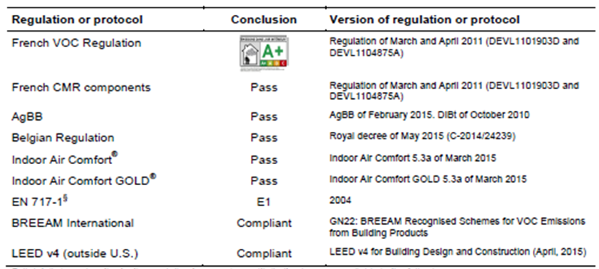

REACH Regulation (EU/1907/2006):
  - does not contain any substances mentioned in the candidate list of SVHC substances or which are mentioned in Annex XIV or Annex XVII of the regulation.
  - HeartFelt® Linear felt is not subjected to the requirement to supply REACH information to downstream users.

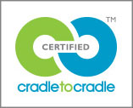
C2C certification:
  - HeartFelt® Linear felt ceilings and walls are made from a single material (virgin PES fibres) without any finishes.
The carriers are made from coated material (aluminium) and can easily be re-used or for 100% recycled. Cradle to Cradle Certified™ Bronze for the complete system has been awarded.
http://www.c2ccertified.org/products/scorecard/ceiling-systems-hunter-douglas-europe-b.v

Oekotex® Confidence in Textiles - Standard 100 – Tested for harmful substances certification:
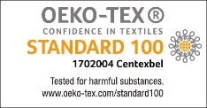
  - The Trevira CS fibres are already Oekotex Standard 100 certified (product class I, babies and small children up to the age of 3 year). Certificate 12.0.03665, validity date 31 March 2020.
  - Oekotex Standard 100 certification for product class IV (furnishing materials for decorative purposes) for the HeartFelt® panels. Certificate 170.0.2004, valid till 28 February 2020.


Sundahus certification:
- The HeartFelt® Linear felt ceiling and wall is a class A product according the Swedish Sundahus Miljödata classification.

Greenguard by UL Laboratories
- The GREENGUARD Certification Program (formerly known as GREENGUARD Indoor Air Quality Certification) gives assurance that products designed for use in indoor spaces meet strict chemical emissions limits, which contribute to the creation of healthier interiors.
  - UL 2818 - 2013 Standard for Chemical Emissions for Building Materials, Finishes and Furnishings, certificate valid till 16 February 2020.
  - UL 2818 - 2013 Gold Standard for Chemical Emissions for Building Materials, Finishes and Furnishings, certificate valid till 16 February 2020.
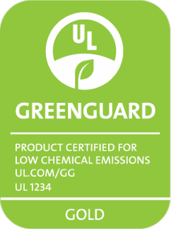 | 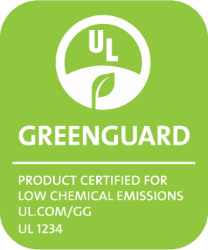

Staining/ Clean ability/ Dirt retention:
  - The tested colour (7599 Anthracite) has a high resistance to staining by chlorinated water (colour comparison after 1 hour exposure to 50mg active chlorine per litre water)
  - Clean ability tests with standardised pollutions and different cleaning agents shows that HeartFelt® Linear felt walls has (wet) cleaning characteristics that are at least at par or better than aluminium ceilings (plain strip 0280). Moderate to strong fuzzing/ pilling may occur depending on the number of rubbings applied. Scratching of the aluminium material occurs when exposed to the same treatment.
  - Dirt retention with standard pollutions on HeartFelt material, compared with plain aluminium, is ca 5-8 higher (weight-to-weight) after shake-off.

Bacterial growth/ fungal growth:
- Depending on bacterial strain the material may/ may not show a propensity to bacterial growth. We advise to consult with the client concerning the bacterial strain(s) that is (are) relevant for the project and need to be tested.
- The felt material does not show any visual or microscopic fungal sporulation or growth.

Maintenance:
- Heartfelt® Linear felt walls can be dry-cleaned with a feather duster or by vacuuming the panels.
- If necessary panels can be wet cleaned with plain water or cleaning agents (see above).

Light reflection according EN 410:

Colour | Reflectance_SOLAR (%) | Reflectance_VIS (%)
7575 (crème) | 46.7 | 39.4
7576 (light brown) | 33.8 | 28.3
7577 (medium brown) | 24.1 | 17.5
7578 (dark brown) | 20.6 | 13.3
7579 (umber) | 15.7 | 9.5
7593 (white) | 59.7 | 60.7
7596 (light grey | 32.2 | 31.8
7597 (medium grey) | 20.3 | 20.6
7598 (dark grey) | 8.9 | 8.5
7594 (black) | 3.6 | 3.5

Colour fastness to artificial light according ISO 105-B02:2014:

Colour | Colour fastness | Colour | Colour fastness
7593 (white) | 8 | 7575 (crème) | 7
7596 (light grey | 8 | 7576 (light brown | 7
7597 (medium grey) | 8 | 7577 (medium brown) | 7
7598 (dark grey) | 8 | 7578 (dark brown) | 7
7594 (black) | 8 | 7579 (umber) | 7

Virgin material means made from new fibres. Due to the fire retardant properties of the fibres it is not possible to use recycled material. Also the mandatory chemical analysis of the material for C2C certification makes it virtually impossible to work with fibres from recycled material.
Cradle to Cradle Certified™ is a certification mark licensed by the Cradle to Cradle Products Innovation Institute.
All test results are based on comparison of the change in colour/ surface of original (nontreated/ exposed) samples to tested samples.

